BEEE EVALUATION

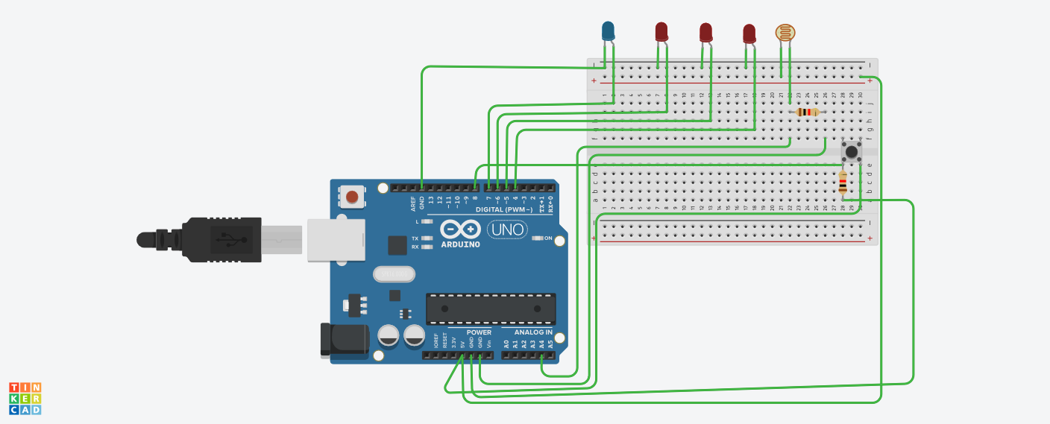**Circuit Diagram**:

**Theory:**

Concepts Used:

1.Coding Arduino.

2.Working with breadboard.

**Learning & Observations**:

Learned the use of breadboard.Understood the use of LDR. Understood the working of Arduino.

There are many uses of Arduino in electronic field . We can make many useful devices like drones using Arduino.

**Problems & Troubleshooting**

There was some problem with ldr ,solved it.

**Precautions**

1. Declare pins used .
2. Connect ldr properly

**Learning Outcomes**

Learned Arduino coding and it was really fun.Understood the uses of Arduino . Things I learned will be very useful.

Learned the use of ldr.

CODE

void setup()  
{  
 pinMode(8,INPUT);  
 pinMode(0,OUTPUT);  
 pinMode(1,OUTPUT);  
 pinMode(2,OUTPUT);  
 pinMode(3,OUTPUT);  
 pinMode(A4,INPUT);  
 Serial.begin(9600);  
}  
  
void loop()  
{  
 int d=digitalRead(8);  
 if(d==1)  
 {  
 int value=analogRead(A4);  
 Serial.print(value);  
 delay(5);  
 Serial.print("\n");  
delay(5);  
 for(int j=4;j<=7;j++)  
 {  
 digitalWrite(j,LOW);  
 }  
 if(value<=350)  
 {  
 for(int j=4;j<=7;j++)  
 {  
 digitalWrite(j,HIGH);  
 }  
 }  
 else  
 {  
 digitalWrite(7,HIGH);   
 }  
 }  
 }